SRM AP UNIVERSITY

Introduction to Programming Using C

CSE 105L

Project Report on

“RESTAURANT BILLING SYSTEM”

Submitted by:

YASHMITHA SRI VUDATHU - AP21110010678

NIHARIKA JUTTUKA - AP21110010681

Under the guidance

Mrs .USHA RANI

Project Mentor

Index

1. Introduction of the project……………………………………………………….3
2. Objectives of the project…………………………………………………………. 3
3. System requirements………………………………………………………………4
4. Process logic………………………………………………………………………….5
5. System design……………………………………………………………………….6
6. Database coding…………………………………………………………………….7
7. Sample screenshots…………………………………………………………….20
8. References…………………………………………………………………………21

Introduction To the Project

The project "Restaurant Billing System" is a basic program used in restaurants .The main aim is to perform the process of ordering and billing of a “Restaurant”. This system is named as Restaurant Billing System. This is designed especially for a restaurant which wants to attend their customers in a very well manner. This system had the capability to give the receipt, in which GST is also included, to the customers. The program is easily executable and can be easily accessed by a user. It is great software for saves times and decreases the work of the restaurants.

Objectives of the project

The main objective of the Restaurant billing system is to manage the details of bills, Payment, customer. It manages all the information about order, cash, total, taxes etc. Th purpose of the project is to build an application program to reduce the manual work for managing the Bills, Payment, orders, total etc. To provide a computer-based billing system for an accurate computation of bills. To reduce the time, energy, and resources that was being consumed when performing a billing for the customer. To generate a receipt when performing a service. To provide a convenient solution of billing pattern.

SYSTEM REQUIREMENTS

Hardware Requirements:

|  |  |
| --- | --- |
| Component | Used by us |
| Language used | C programming |
| Operating system | Windows |
| Processor | Intel processor I5 |
| RAM | 16GB |
| SSD | 512GB |

Software Requirements:

|  |  |
| --- | --- |
| Components | Used by us |
| Operating system | Windows 10 |
| Server | Windows home |
| Compiler | DEV C++ |
| Presentation tool | Microsoft word |
| Documentation tool | Microsoft word |

***Process logic***

Start

Types of menu choice

Dinner

Breakfast

Lunch

Stop

The overall bill is shown

Menu is again appeared

Food items are selected

Menu is shown

Quantity is selected

***SYSTEM DESIGN***

Step 1 - Start

Step 2 - The meal is selected as per choice (breakfast, lunch, dinner)

Step 3 - The menu is shown

Step 4 - The food item is selected

Step 5 - The quantity of food item is selected

Step 6 - "Will you like to buy anything?" is shown

Step 7 - Yes or no is selected

Step 8 - If the selected option is yes, step 2 repeated

Step 9 - If the selected option is no, the bill with taxes added is shown

Step 10 - The total amount is shown

Step 11 - Stop

Database Coding

#include<stdio.h>

#include<stdlib.h>

int again;

int total=0;

float gst,cgst,sgst;

int bfrate[7][2]={ {0,30},

{1,35},

{2,40},

{3,20},

{4,15},

{5,20},

{6,30}

};

int lunchrate[7][2]={{0,80},

{1,120},

{2,20},

{3,120},

{4,150},

{5,160},

{6,30}};

int dinner_rate[7][2]={{0,65},

{1,50},

{2,70},

{3,80},

{4,65},

{5,110},

{6,50}};

int purchased[][3]={{0,0},

{0,0},

{0,0},

{0,0},

{0,0},

{0,0},

{0,0}

};

int temp[][3]={{0,0},

{0,0},

{0,0},

{0,0},

{0,0},

{0,0},

{0,0}

};

void bfast(char bfmenu[][100]);

void lunch( char lunchmenu[][100]);

void dinner(char dinnermenu[][100]);

void main_menu();

void display();

void lunch_menucard();

void dinner_menu();

void display_bf_bill(char bfmenu[][100]);

void display_lunch_bill(char lunchmenu[][100]);

void display_dinner_bill(char dinnermenu[][100]);

void display_bfmenu();

void repeatbf(char bfmenu[][100]);

void repeatlunch(char lunchmenu[][100]);

void repeatdinner(char dinnermenu[][100]);

void display_total_words();

void main()

{

char bfmenu[][100]={"Idli","vada","Dosa","Upma","milk","tea","coffee"};

char lunchmenu[][100]={"chicken Biryani","Special meals","Roti","Dal","Paneer Tikka","Veg mix","Icecream"};

char dinnermenu[][100]={"Fried rice","Spegatti","Burger"};

char choice;

do

{

enter:

display();

printf("Enter your choice here : ");

scanf("%c", &choice);

getchar();

switch(choice)

{

case 'A':

case 'a':printf("\nBreakfast\n");

bfast(bfmenu);

break;

case 'B':

case 'b':printf("\nLunch\n");

lunch(lunchmenu);

break;

case 'C':

case 'c':printf("\nDinner\n");

dinner(dinnermenu);

break;

default:printf("\nWrong choice entered Please enter the valid choice!!\n");

goto enter;

}

}while(choice!='d');

}

void display()

{

printf(" Welcome to KIYOMI Restaurant. \n ");

printf(" +============================+ \n\n");

printf(" && Please select the meal that you would like to purchase.&& \n\n");

printf("\t\t [A] Breakfast\n");

printf("\t\t [B] Lunch\n");

printf("\t\t [C] Dinner\n");

}

void display_bfmenu()

{

printf(" Welcome to KIYOMI Restaurant. \n ");

printf(" +============================+ \n\n");

printf(" $ Breakfast Menu $ \n\n");

printf(" && Please select the food that you would like to purchase. && \n\n");

printf("\t\t [0] Idli - Rs 30.00\n");

printf("\t\t [1] Vada - Rs 35.00\n");

printf("\t\t [2] Dosa - Rs 30.00\n");

printf("\t\t [3] upma- Rs 25.00\n");

printf("\t\t [4] Milk- Rs 15.00\n");

printf("\t\t [5] Tea - Rs 20.00\n");

printf("\t\t [6] Coffee - Rs 30.00\n");

}

void bfast(char bfmenu[][100]) //Breakfast Menu Screen

{

int choice = 0; //local variables

int quantity = 0;

int again = 0,amt=0;

int code,i;

display_bfmenu();

printf("\nEnter the code:: ");

scanf("%d", &code);

getchar();

if(code>=0&&code<=6)

{

printf("\nEnter the quantity::");

scanf("%d",&quantity);

purchased[code][1]= quantity*bfrate[code][1]; /*purchased[code][1]+ (quantity*bfrate[code][1]);*/

total+=purchased[code][ 1];

gst=total*0.12;

cgst=gst/2;

sgst=cgst;

total=purchased[code][ 1]+gst;

}

else

{

printf("\nInvalid code entered, Please enter the code again!!!!\n\n");

bfast(bfmenu);

}

repeatbf(bfmenu);

}

void repeatbf(char bfmenu[][100])

{

printf("\nWould you like to buy anything else?\n[1] Yes , [2] No : "); // Allows user to choose whether to check-out or buy anything else.

scanf("%d",&again);

if (again == 1)

bfast(bfmenu);

else if (again == 2 )

{

display_bf_bill(bfmenu);

exit(0);

}

else

{

printf("\n\n\t\tSorry Invalid Decision Entered\n");

repeatbf(bfmenu);

}

}

void display_bf_bill(char bfmenu[][100])

{

int i;

printf(" +~~~~~~~~+ \n\n");

printf(" KIYOMI RESTAURANT \n");

printf(" BILLING INFORMATION \n");

printf("\t\t ITEMS\t\tPrice(in Rs.)\n");

for(i=0;i<7;i++)

{

if(purchased[i][1]!=0)

{

printf("\t\t%s\t\t",bfmenu[i]);

printf("%d\n",purchased[i][1]); /*purchased[i][1]);*/

}

}

printf("\t\tGST=Rs.%0.2f\n",gst);

printf("\t\tC-GST=Rs.%0.2f\n",cgst);

printf("\t\tS-GST=Rs.%0.2f\n",sgst);

printf("\t\tTotal=Rs.%d\n",total);

display_total_words();

printf("\n\n +~~~~~~~~+ \n\n");

}

void display_lunch_bill(char lunchmenu[][100])

{

int i;

printf(" +~~~~~~~~+ \n\n");

printf(" KIYOMI RESTAURANT \n");

printf(" BILLING INFORMATION \n");

printf("\t\t ITEMS\t\t\tPrice(in Rs.)\n");

for(i=0;i<7;i++)

{

if(purchased[i][1]!=0)

{

printf("\t\t %s \t\t",lunchmenu[i]);

printf("%d\n",purchased[i][1]);

}

}

printf("\t\tGST=Rs.%0.2f\n",gst);

printf("\t\tC-GST=Rs.%0.2f\n",cgst);

printf("\t\tS-GST=Rs.%0.2f\n",sgst);

printf("\t\tTotal=Rs.%d\n",total);

display_total_words();

printf("\n\n +~~~~~~~~+ \n\n");

}

void display_dinner_bill(char dinnermenu[][100])

{

int i;

printf(" +~~~~~~~~+ \n\n");

printf(" KIYOMI RESTAURANT \n");

printf(" BILLING INFORMATION \n");

printf("\t\t ITEMS\t\t\tPrice(in Rs.)\n");

for(i=0;i<7;i++)

{

if(purchased[i][1]!=0)

{

printf("\t\t %s \t\t",dinnermenu[i]);

printf("%d\n",purchased[i][1]);

}

}

printf("\t\tGST=Rs.%0.2f\n",gst);

printf("\t\tC-GST=Rs.%0.2f\n",cgst);

printf("\t\tS-GST=Rs.%0.2f\n",sgst);

printf("\t\tTotal=Rs.%d\n\n",total);

display_total_words();

printf("\n\n +~~~~~~~~+ \n\n");

}

void lunch(char lunchmenu[][100]) // Lunch Screen Menu

{

int choice = 0; //local variables

int quantity = 0;

int again = 0,amt=0;

int code,i;

lunch_menucard();

printf("\nEnter the code:: ");

scanf("%d", &code);

getchar();

if(code>=0&&code<=6)

{

printf("\nEnter the quantity::");

scanf("%d",&quantity);

// purchased[code][1]= purchased[code][1]+(quantity*lunchrate[code][1]);

purchased[code][1]= quantity*lunchrate[code][1];

total+=purchased[code][ 1];

gst=total*0.12;

cgst=gst/2;

sgst=cgst;

total=purchased[code][ 1]+gst;

}

else

{

printf("\nInvalid code entered, Please enter the code again!!!!\n\n");

lunch(lunchmenu);

}

repeatlunch(lunchmenu);

}

void dinner(char dinnermenu[][100]) // Dinner Menu Screen

{

int choice = 0; //local variables

int quantity = 0;

int again = 0,amt=0;

int code,i;

dinner_menu();

printf("\nEnter the code:: ");

scanf("%d", &code);

getchar();

if(code>=0&&code<=6)

{

printf("\nEnter the quantity::");

scanf("%d",&quantity);

// purchased[code][1]= purchased[code][1]+(quantity*dinner_rate[code][1]);

purchased[code][1]= quantity*dinner_rate[code][1];

total+=purchased[code][ 1];

gst=total*0.12;

cgst=gst/2;

sgst=cgst;

total=purchased[code][ 1]+gst;

}

else

{

printf("\nInvalid code entered, Please enter the code again!!!!\n\n");

dinner(dinnermenu);

}

repeatdinner(dinnermenu);

}

void lunch_menucard()

{

printf(" Welcome to KIYOMI Restaurant. \n ");

printf(" +============================+ \n\n");

printf(" $ Lunch Menu $ \n\n");

printf(" && Please select the food that you would like to purchase. && \n\n");

printf("\t\t [0] chicken biriyani - Rs 80.00\n");

printf("\t\t [1] Special Meals - Rs 120.00\n");

printf("\t\t [2] Roti - Rs 20.00\n");

printf("\t\t [3] Dal tadka - Rs 120.00\n");

printf("\t\t [4] paneer tikka - Rs 150.00\n");

printf("\t\t [5] Veg Mix - Rs 160.00\n");

printf("\t\t [6] Ice cream - Rs 30.00\n");

printf("Enter your choice here : ");

}

void dinner_menu()

{

printf(" Welcome to KIYOMI Restaurant. \n ");

printf(" +============================+ \n\n");

printf(" $ Dinner Menu $ \n\n");

printf(" && Please select the food that you would like to purchase. && \n\n");

printf("\t\t [0] Fried Rice - Rs 65.00\n");

printf("\t\t [1] curd rice - Rs50.00\n");

printf("\t\t [2] meals - Rs 70.00\n");

printf("\t\t [3] chicken biriyani - Rs 80.00\n");

printf("\t\t [4] poha - Rs 65.00\n");

printf("\t\t [5] Paratha - Rs 110.00\n");

printf("\t\t [6] Fruit Salad - Rs 50.00\n");

}

void repeatlunch(char lunchmenu[][100])

{

printf("\nWould you like to buy anything else?\n[1] Yes , [2] No : "); // Allows user to choose whether to check-out or buy anything else.

scanf("%d",&again);

if (again == 1)

lunch(lunchmenu);

else if (again == 2 )

{

display_lunch_bill(lunchmenu);

exit(0);

}

else

{

printf("\n\n\t\tSorry Invalid Decision Entered\n");

repeatlunch(lunchmenu);

}

}

void repeatdinner(char dinnermenu[][100])

{

printf("\nWould you like to buy anything else?\n[1] Yes , [2] No : "); // Allows user to choose whether to check-out or buy anything else.

scanf("%d",&again);

if (again == 1)

{

dinner(dinnermenu);

}

else if (again == 2 )

{

display_dinner_bill(dinnermenu);

exit(0);

}

else

{

printf("\n\n\t\tSorry Invalid Decision Entered\n");

repeatdinner(dinnermenu);

}

}

void display_total_words()

{

int num=0,digits=0,temp=0;

while(total != 0)

{

num=(num * 10)+(total % 10);

total/= 10;

digits++;

}

printf("\nNo of digits::%d\n",digits);

while(num!= 0)

{

temp++;

switch(num%10)

{

case 0:

printf("Zero ");

break;

case 1:

printf("One ");

break;

case 2:

printf("Two ");

break;

case 3:

printf("Three ");

break;

case 4:

printf("Four ");

break;

case 5:

printf("Five ");

break;

case 6:

printf("Six ");

break;

case 7:

printf("Seven ");

break;

case 8:

printf("Eight ");

break;

case 9:

printf("Nine ");

break;

}

num = num / 10;

}

if(num==0&&digits!=temp)

printf(" Zero ");

return;

}

**Sample screenshots**

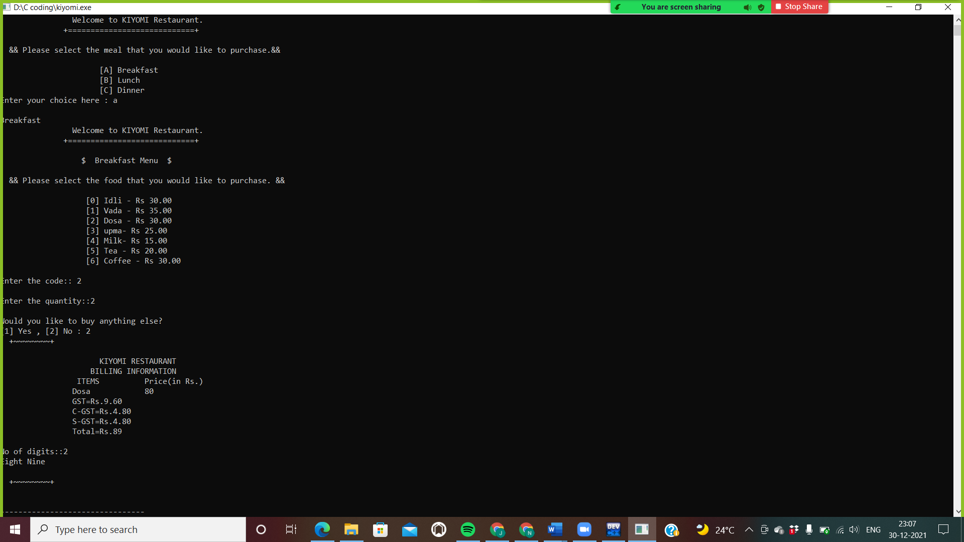

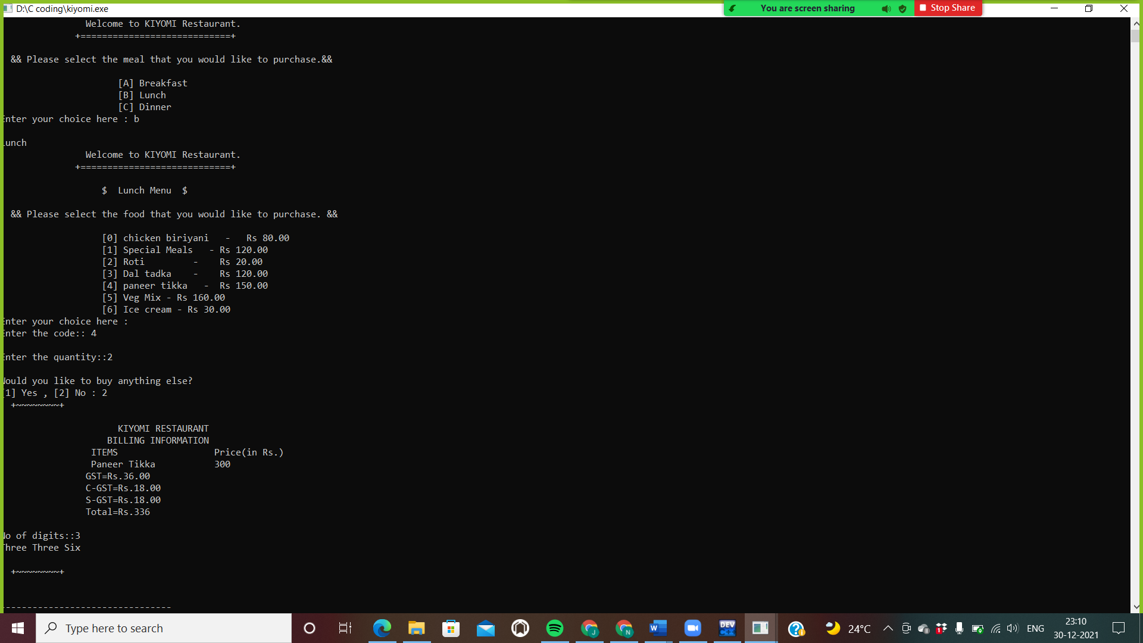

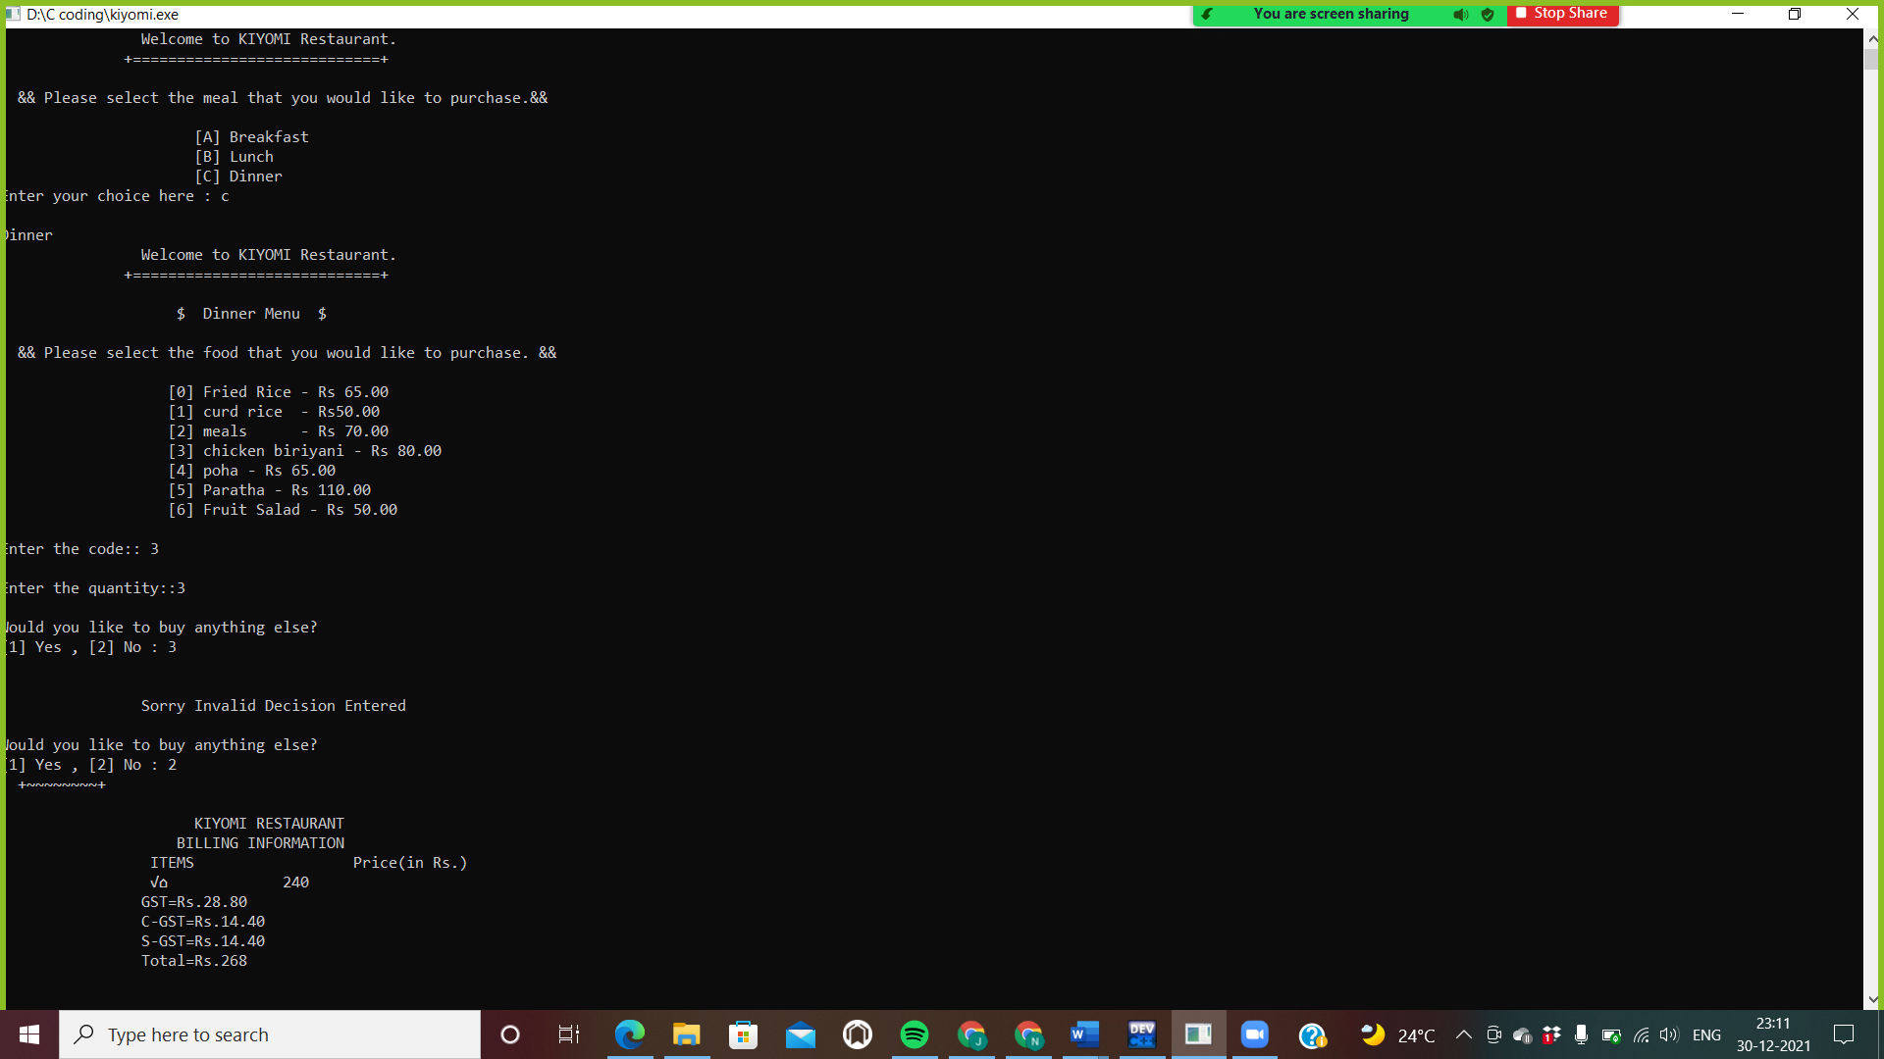

References:

[www.tutorialspoint.com](http://www.tutorialspoint.com)

__The end___